LAMBDA 👍

### **AWS Lambda**

### **Definition**

**AWS Lambda** is a service that lets you run code without having to manage servers. You just write your code, and AWS Lambda runs it for you whenever it's needed.

#### **Explanation**

Imagine you have a magic box that can do your homework for you. You tell the box what you need it to do (like solving math problems), and whenever you need help, you just call the box, and it does the work instantly.

AWS Lambda works in a similar way:

1. **You Write the Code**: You write instructions for the magic box (Lambda function). For example, you might tell it to resize a picture or calculate a number.
2. **AWS Takes Care of the Rest**: You don't need to worry about where the box is or how it works. AWS handles all the complicated parts like providing the electricity (computing power) and storage.
3. **It's Fast and On-Demand**: Whenever you need the code to run, you just call it, and it runs immediately. You only pay for the time it takes to do the work.

#### **Example**

Let's say you have a website where people can upload pictures. You want every picture to be resized to fit nicely on the webpage.

* **You Write a Lambda Function**: You write code that resizes pictures.
* **Someone Uploads a Picture**: When a picture is uploaded to your website, AWS Lambda automatically runs your resizing code.
* **Picture is Resized**: The picture is resized and ready to be displayed on your website.

So, AWS Lambda is like having a magical helper that does specific tasks for you whenever you need them, and you only have to tell it what to do without worrying about the details of how it gets done.

### CASE STUDY #####

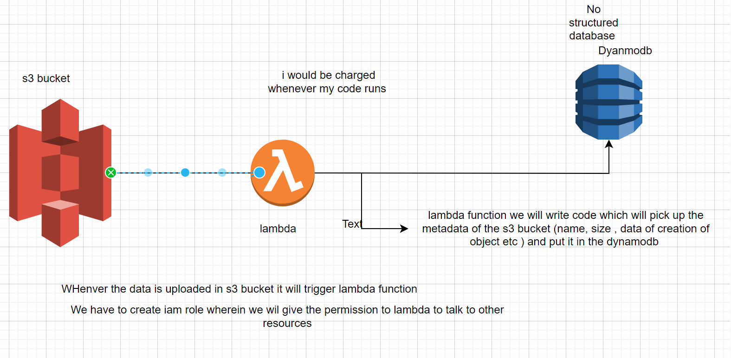

### We will first create s3 bucket

Create bucket

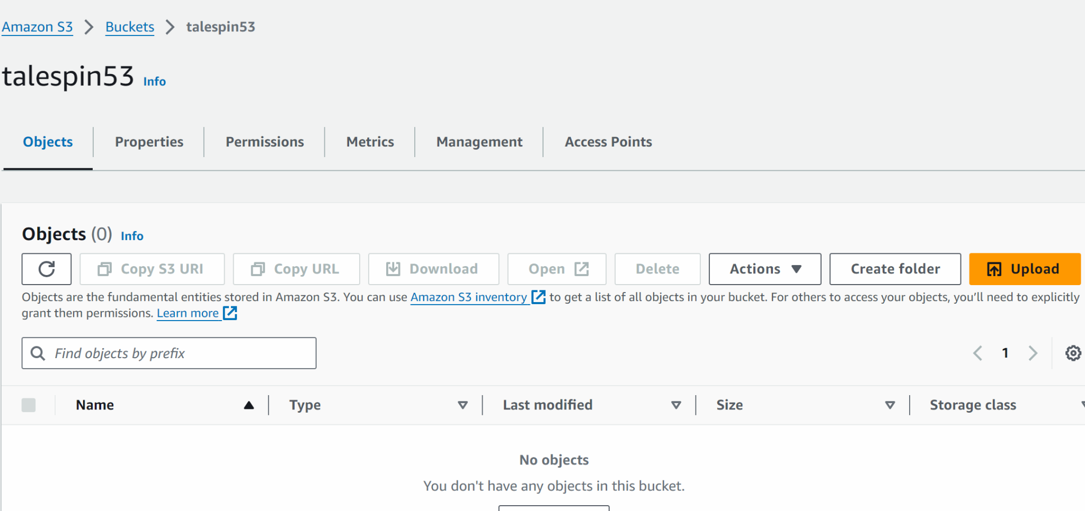

## create a database dynamdb

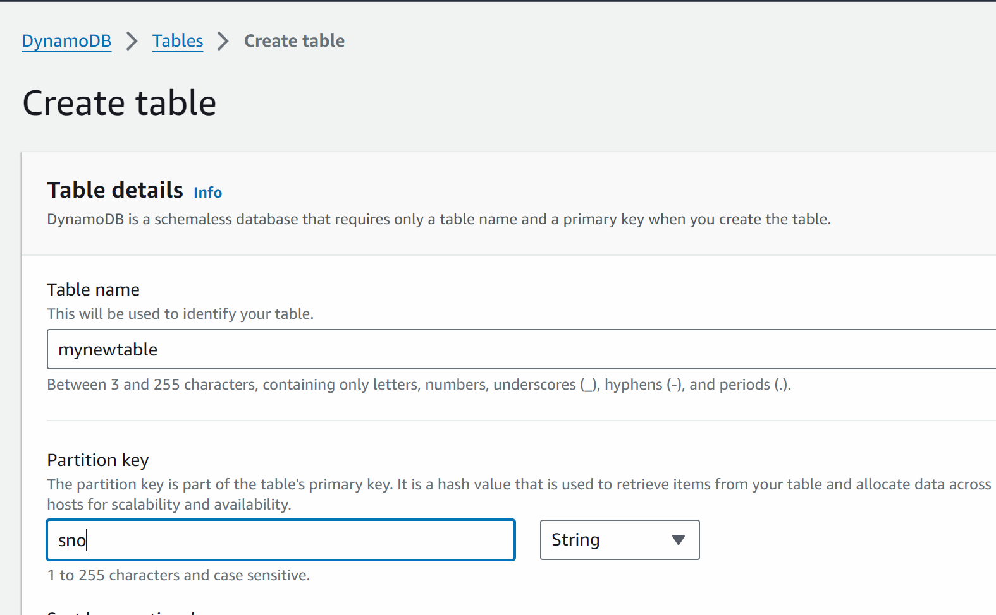

Create table

## we will now create a iam role where we will give the permission to lambda to access other resources (s3 and dynamodb) on our behalf

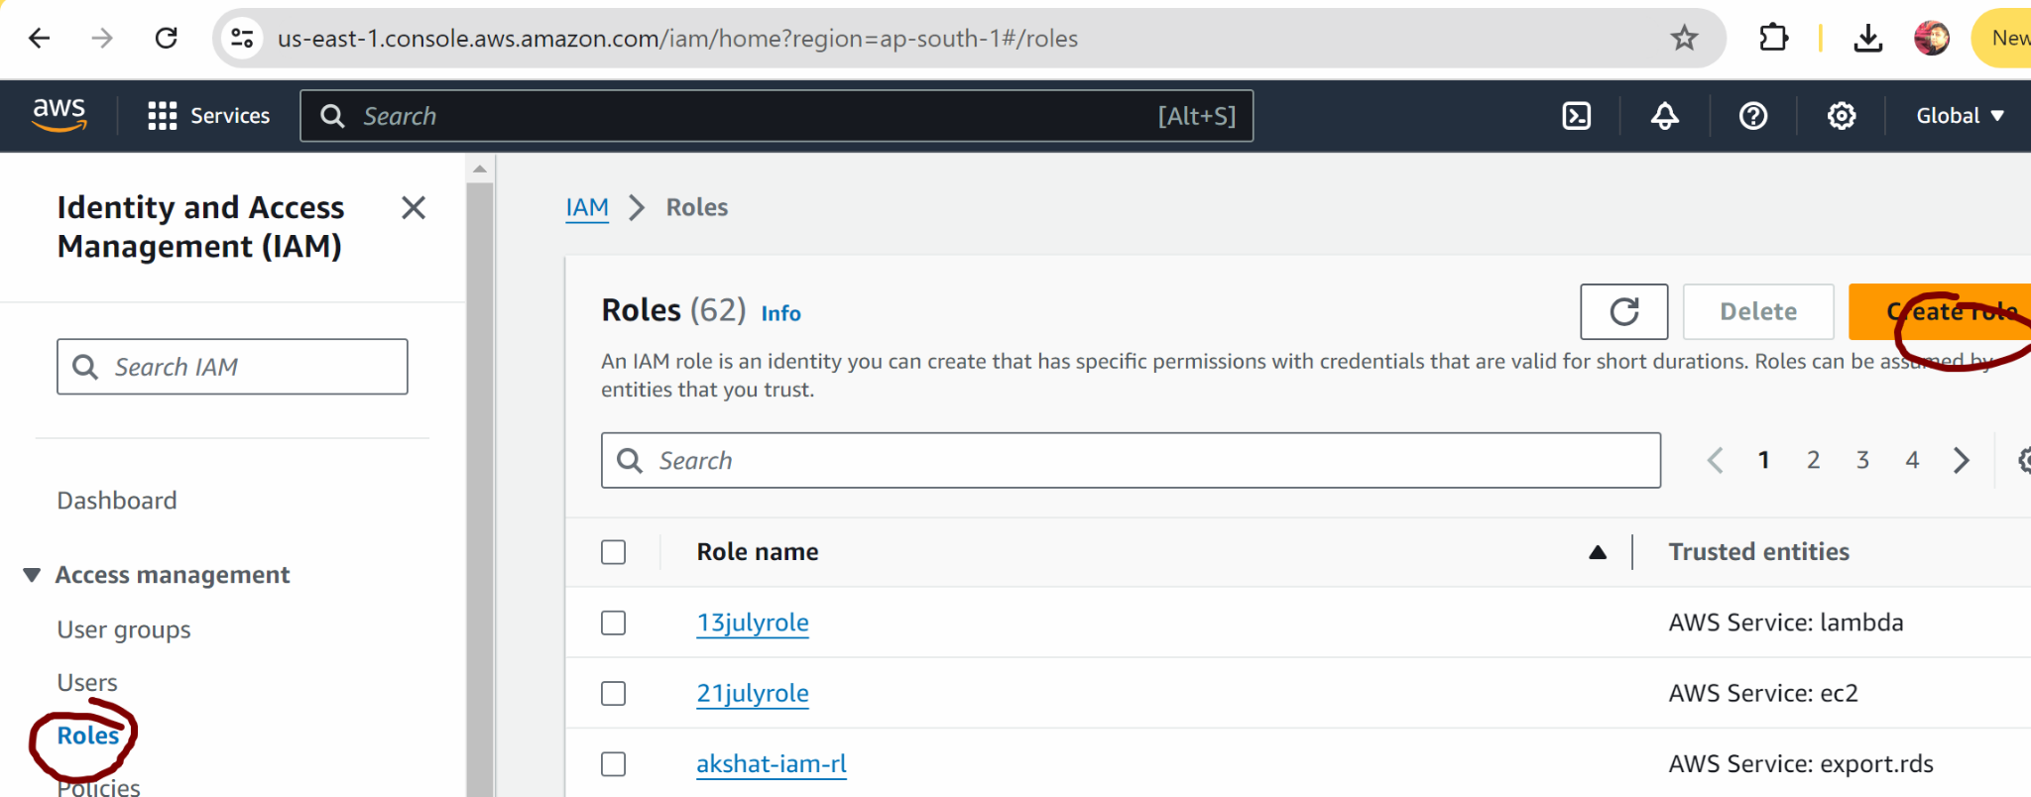

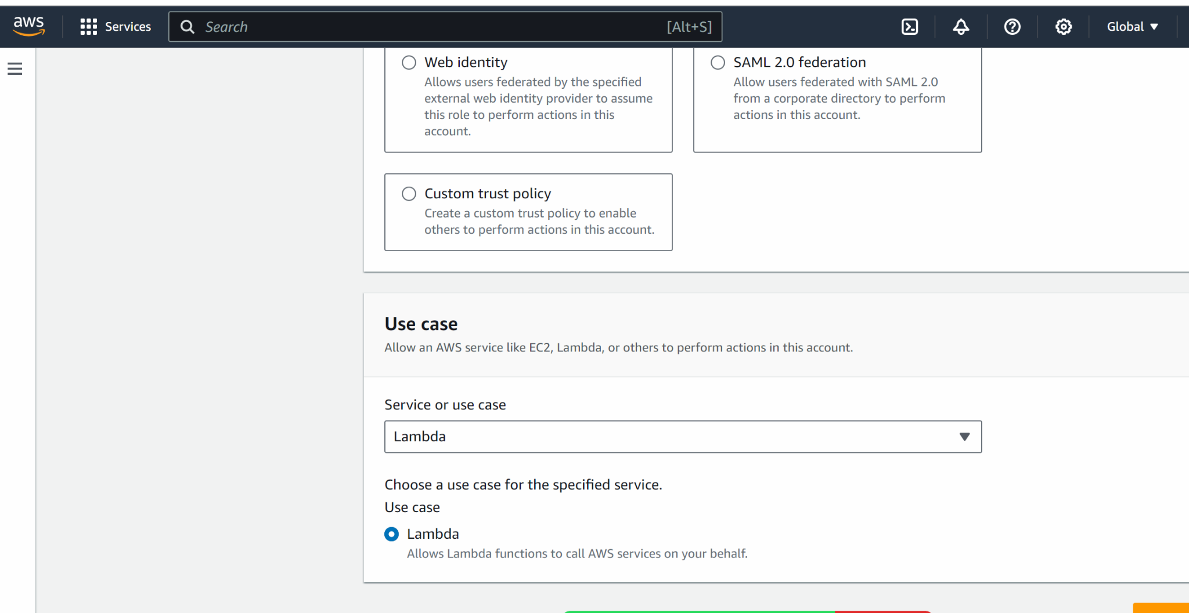

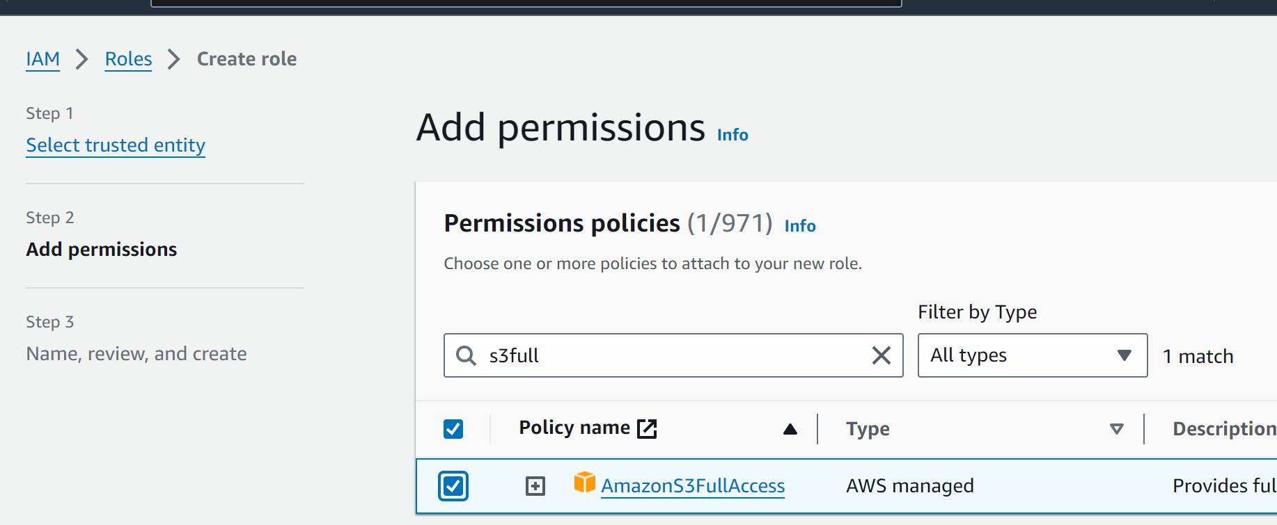

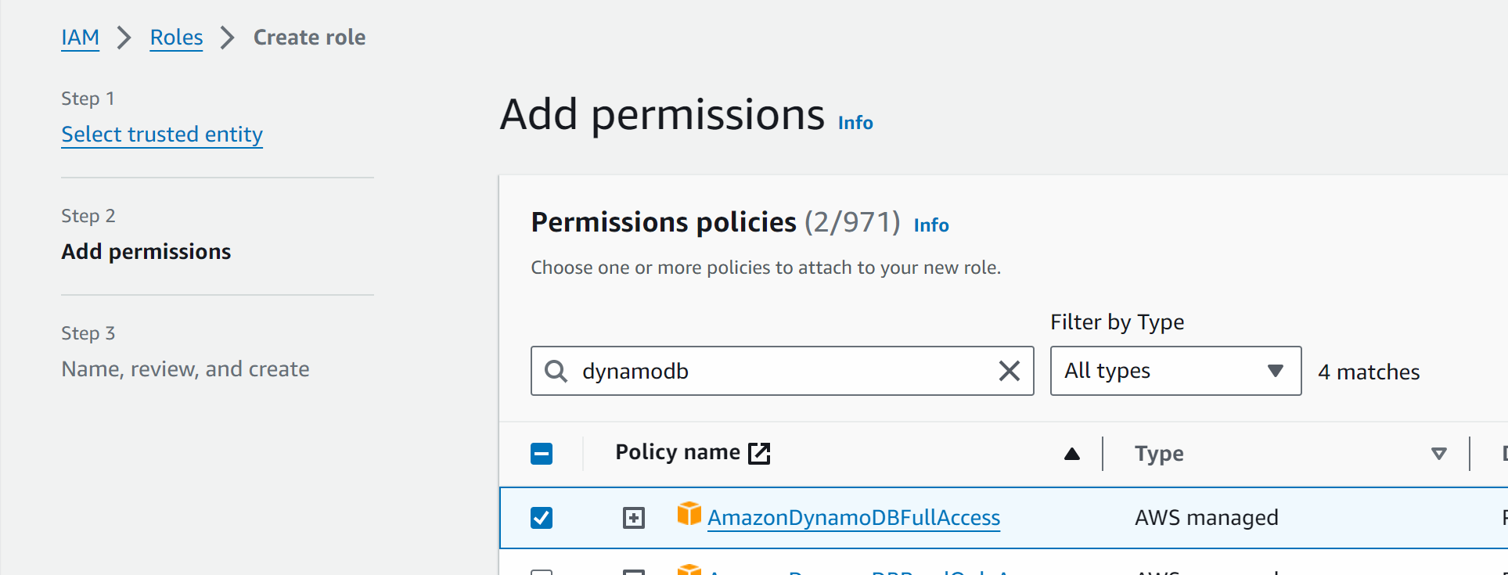

Create role

## now we will create lambda function and to trigger whenever there any event happening the s3

(like uploading any object or deletion of object)

Go to lambda -> create function

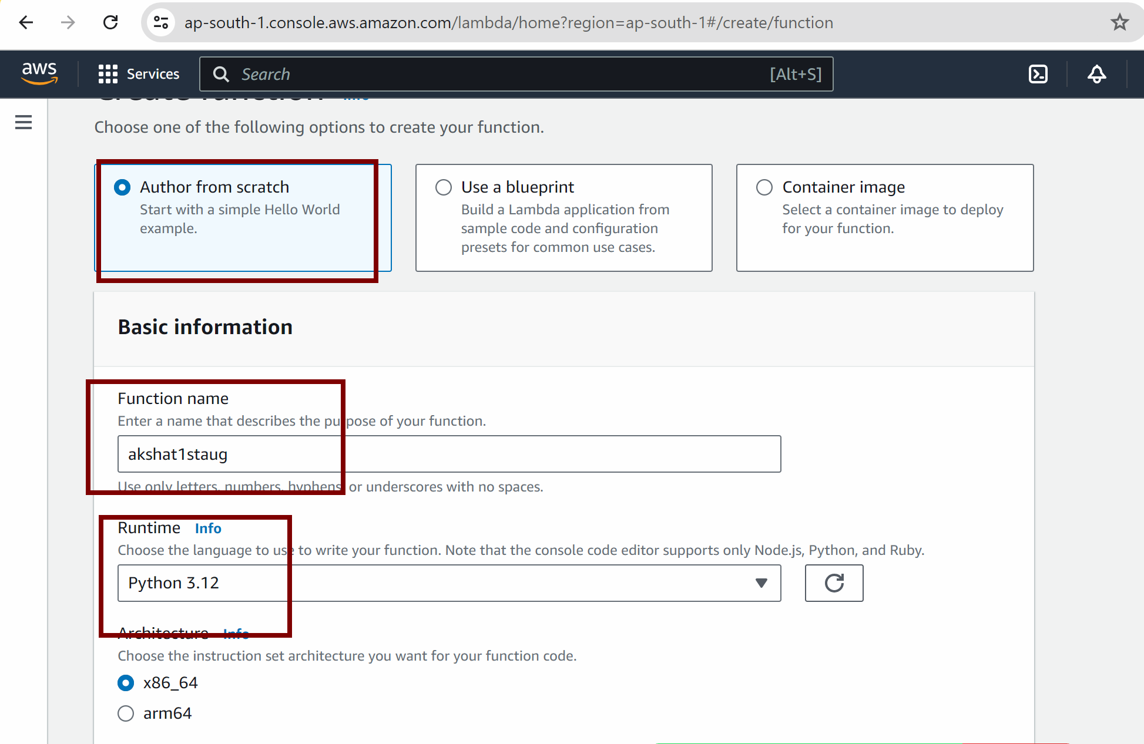

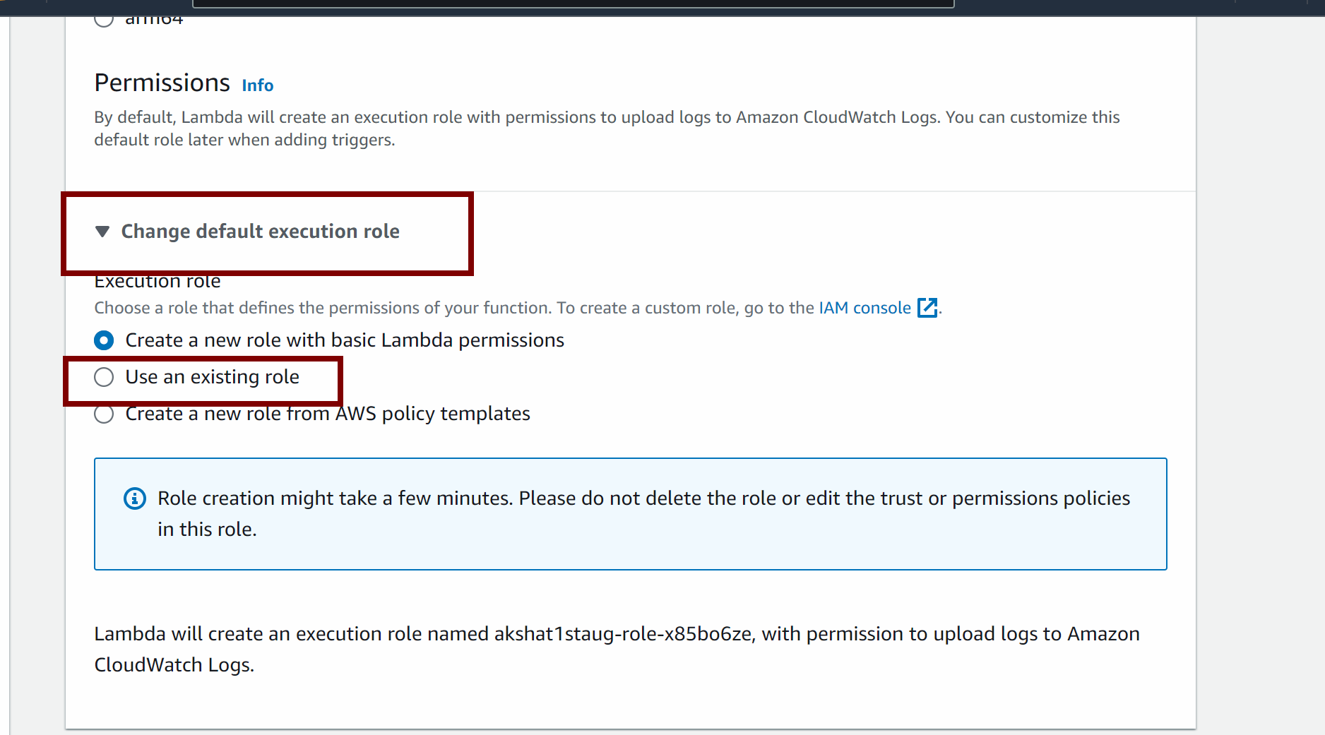

We will attach the role which we created previously

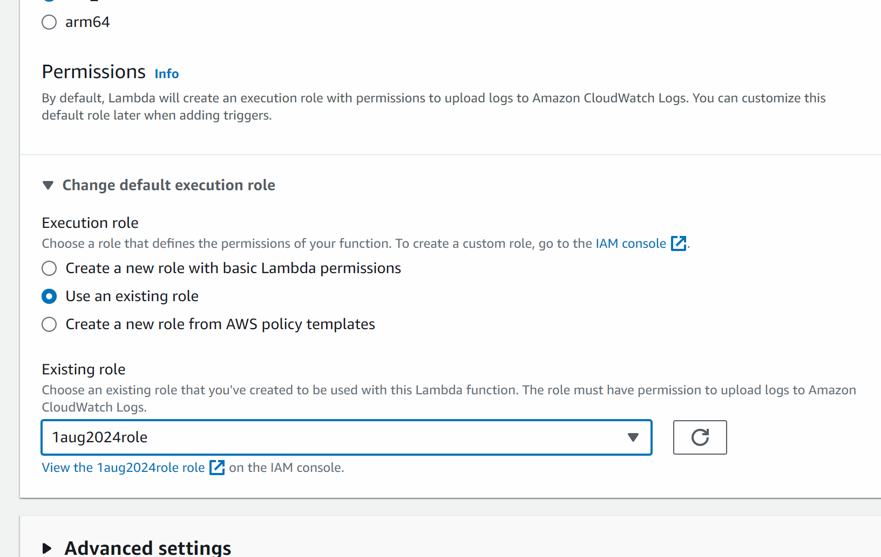

Create function

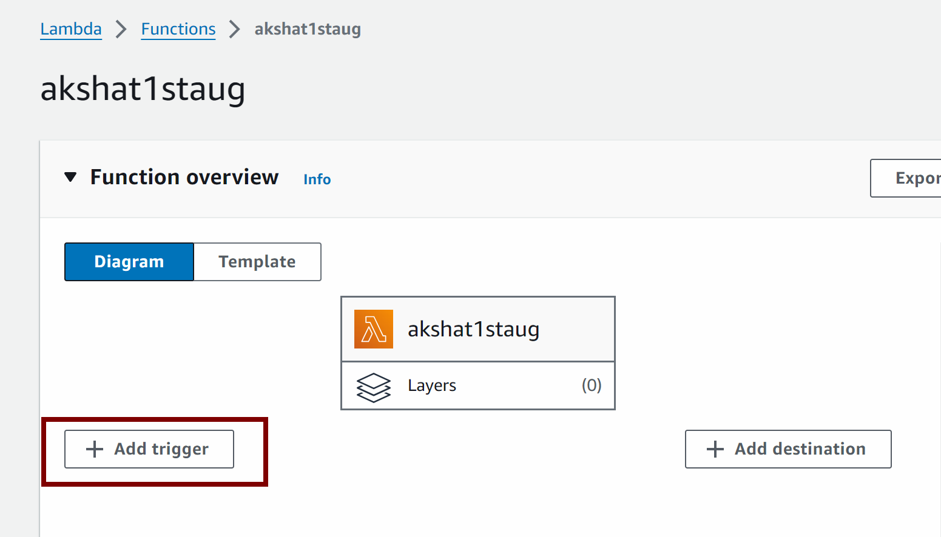

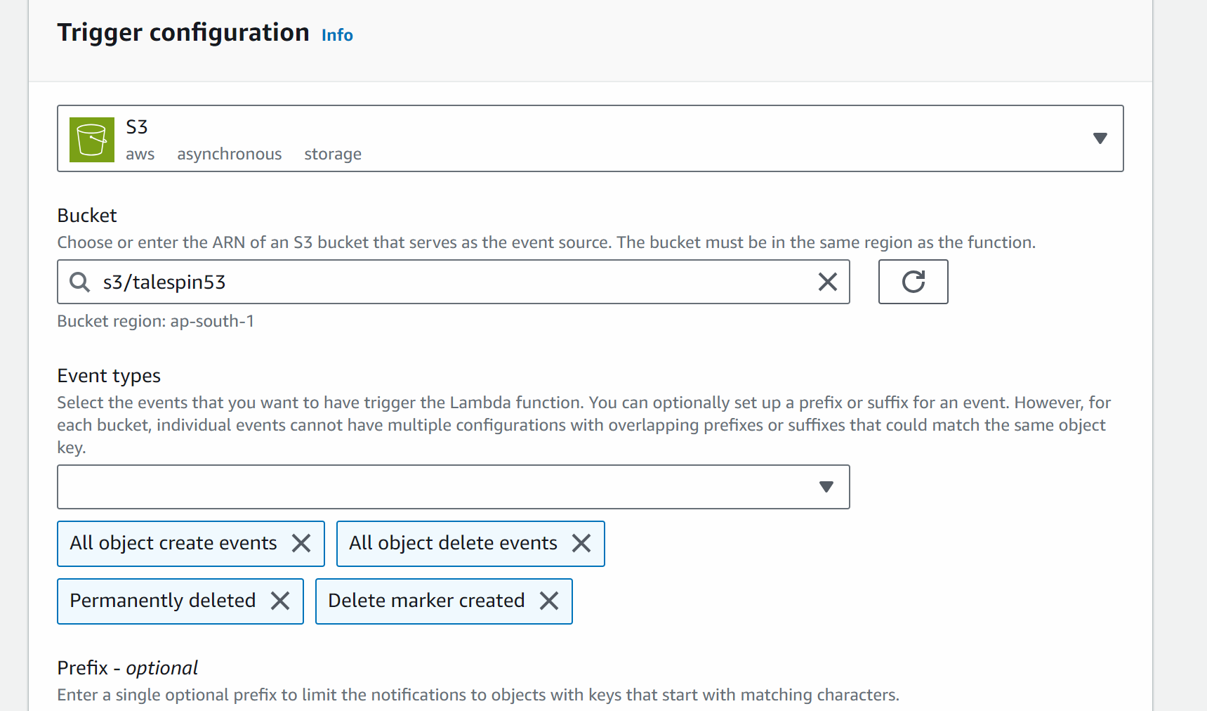

(in event types select all delete events also)

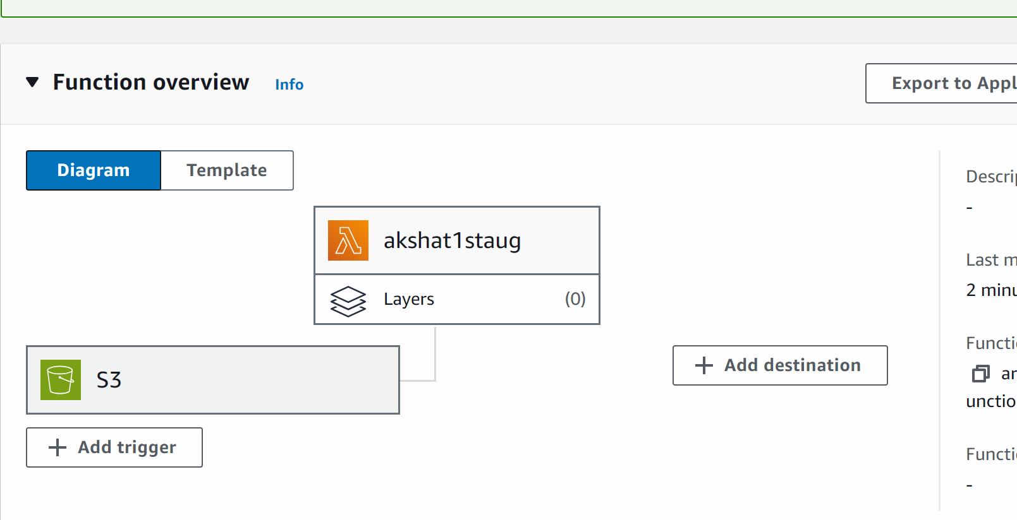

Scroll down and click on code

import boto3

from uuid import uuid4

def lambda_handler(event, context):

s3 = boto3.client("s3")

dynamodb = boto3.resource('dynamodb')

for record in event['Records']:

bucket_name = record['s3']['bucket']['name']

object_key = record['s3']['object']['key']

size = record['s3']['object'].get('size', -1)

event_name = record ['eventName']

event_time = record['eventTime']

dynamoTable = dynamodb.Table('mynewtable')

dynamoTable.put_item(

Item={'sno': str(uuid4()), 'Bucket': bucket_name, 'Object': object_key,'Size': size, 'Event': event_name, 'EventTime': event_time})

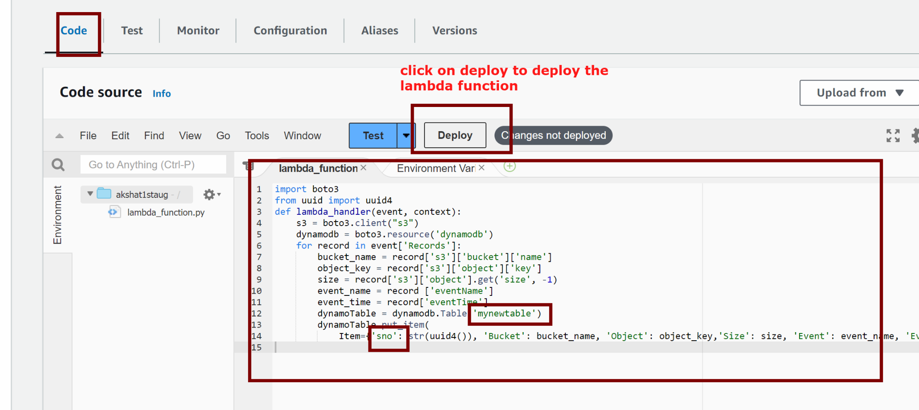

Or press ctrl shift u to deploy

## now lets check if we update anything in s3 whether the dynamodb is getting updated or not

Go to s3 -> click on your bucket

Click on upload button

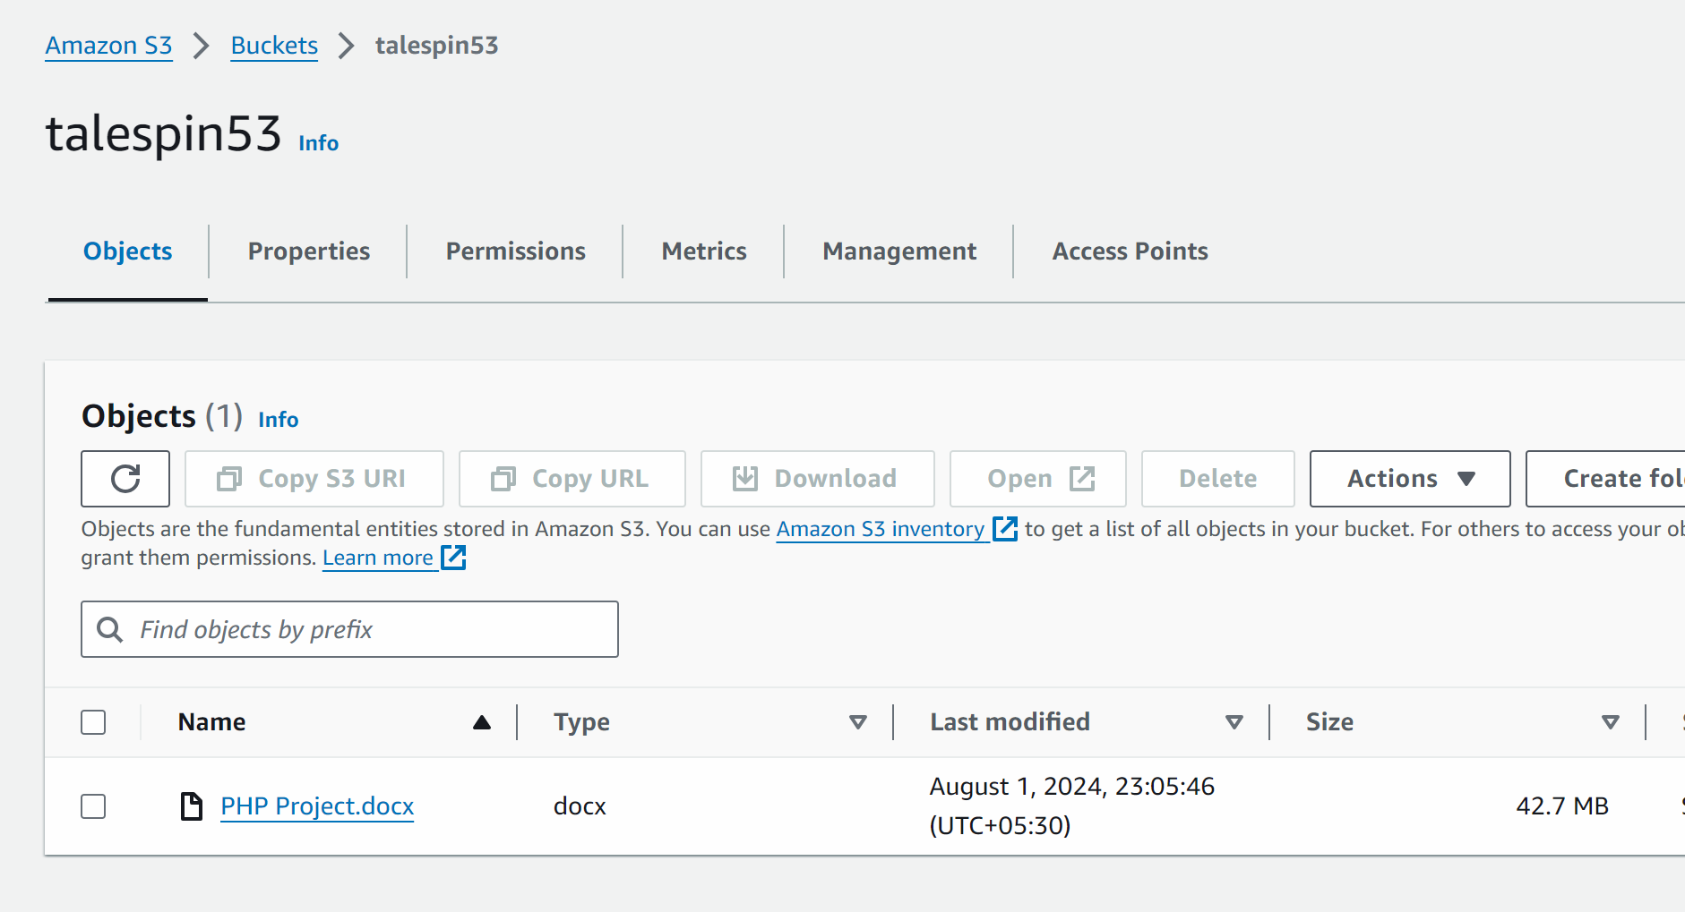

You can upload anything

Now lets go and check dynamodb

